1. **Database name screenshot:**

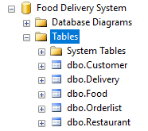

**2.Create five table**

* 1. Customer Table

create table Customer(

CustID int NOT NULL PRIMARY KEY,

CustName varchar (40),

CustAddress varchar (200),

CustPhone nvarchar(20),

CustEmail varchar (40)

);

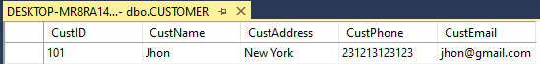

* 1. Restaurant Table

create table Restaurant(

RestID int NOT NULL PRIMARY KEY,

RestName varchar (40),

RestType varchar (40),

RestAddress varchar (60),

RestPhone nvarchar(20),

RestEmail varchar (40),

RestPIC varchar (40)

);



* 1. Food Table

create table Fodd(

FoodID int NOT NULL PRIMARY KEY,

FoodName varchar (40),

FoodType varchar (40),

FoodExpiryHour nvarchar (20),

FoodPrice nvarchar (20),

RestID int NOT NULL REFERENCES Restaurant (RestID)

);

C:\Users\Zeeshan Miran\Downloads\food.PNG

* 1. Orderlist Table

create table Orderlist(

OrderID int NOT NULL PRIMARY KEY,

OrderDate datetime ,

OrderQty int,

OrderAmount nvarchr(20),

FoodID int NOT NULL REFERENCES Food (FoodID),

CustID int NOT NULL REFERENCES Customer (CustID)

);

C:\Users\Zeeshan Miran\Downloads\tbl4.PNG

* 1. Delivery Table

create table Delivery(

DeliveryID int NOT NULL PRIMARY KEY,

DispatchName varchar (40),

DeliveryDate datetime ,

OrderID int NOT NULL REFERENCES Orderlist (OrderID)

);

C:\Users\Zeeshan Miran\Downloads\tbl5.PNG

1. **Insert data into table**
   1. insert into Customer table

insert into Customer (CustID, CustName, CustAddress, CustPhone, CustEmail)

values

(101,’Jhon’,’New York’, 231213123123,’jhon@gmil.com’),

(102,’Adann’,’Chili’, 123123333321 ,’adann@gmil.com’),

(103,’Bream’,’Chicago’, 93223232323,’bream@gmil.com’),

(104,’Dalta’,’Malam’, 324234234222,’dalta@gmil.com’),

(105,’Tream’,’Hedor’, 32424233244,’team@gmil.com’),

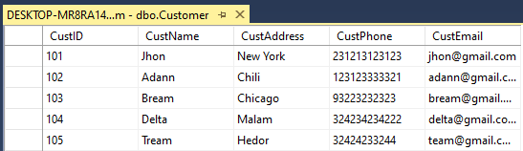

* 1. insert into Restaurant table

insert into Restaurant (RestID, RestName, RestType, RestAddress, RestPhone, RestEmail, RestPIC)

values

(200,’ High ways’,’Fast Food’,’Paris’, 2138912919,’high@gmil.com’,’MASA’),

(201,’ Rangla’,’ Casual dining’,’ NewYork’, 2322131231 ,’rangla@gmil.com’,’ASBS’),

(202,’ Ithaa’,’ Family style’,’ Chicago’, 43332322,’ithaa@gmil.com’,’GERT’),

(203,’ Signs’,’ Ethnic’,’Malam’, 534343434,’signs@gmil.com’,’ZAWR’),

(204,’ Norma’,’Bistro’,’Hedor’, 23232323232,’norma@gmil.com’,’VUPA’),



* 1. insert into Food table

insert into Food (FoodID, FoodName, FoodType, FoodExpiryHour, FoodPrice, RestID)

values

(301,'Pizza','Fast Food',15,25,200),

(302,'Cheese Pizza','Fast Food',12,30,200),

(303,'Dumplings','Casual Dining',22,15,201),

(304,'Rice','Casual Dining',15,22,201),

(305,'Beans','Family Style',24,10,202),

(306,'Fish','Family Style',18,20,202),

(307,'Dim sum','Ethnic',8,17,203),

(308,’Tagine','Ethnic',13,23,203),

(309,’Vegatable','Bistro',24,13,204),

(310,’Goulash','Bistro',18,20,204),

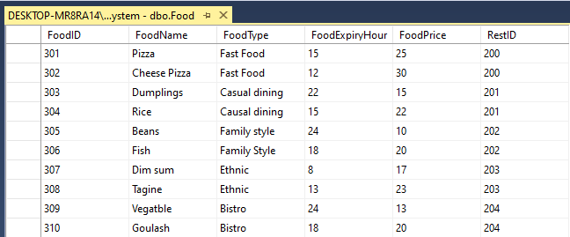

* 1. insert into Orderlist table

insert into Orderlist (OrderID, OrderDate, OrderQty, OrderAmount, FoodID, CustID)

values

(401,2020-12-01,2,60,301,101),

(402,2020-12-10,12,200,302,102),

(403,2020-01-10,3,90,303,103),

(404,2020-03-20,8,240,303,103),

(405,2020-04-20,4,100,306,104),

(406,2020-05-14,2,25,309,105),

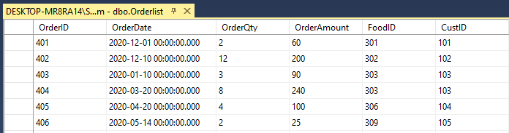

* 1. insert into Delivery table

insert into Delivery (DeliveryID, DispatchName, DeliveryDate, OrderId )

values

(501,’Elarm’,2020-12-01,401),

(502,’Joe’,2020-12-10,402),

(503,’Adan’,2020-01-10,403),

(504,’Happy’,2020-03-20,404),

(505,’Peter’2020-04-20,405),

(506,’Henrry’,2020-05-14,406),

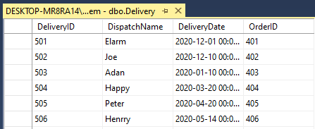

**4.a Food based on FoodType**

Select * from Food order by FoodType;

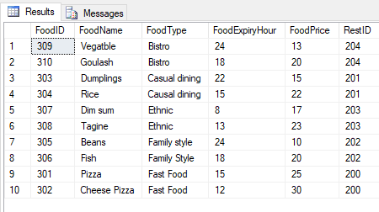

**4.b List all Food supplied by each Restaurant with FoodType “Fast Food”**

select * from Food where FoodType = 'Fast Food';

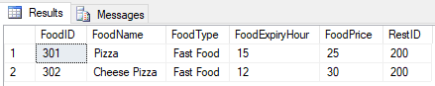

**4.c** **List all customer details who lives in “Chili”**

select * from Customer where CustAddress = 'Chili'

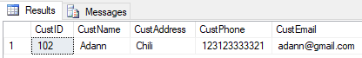

**4.d Produce a Total-Purchase information by getting the overall total purchase for product type “Fast Food”**

SELECT Food.FoodID, Food.FoodType, Orderlist.OrderQty, Orderlist.OrderAmount, Sum([OrderQty]*[OrderAmount]) AS Total

FROM Food INNER JOIN [Orderlist] ON Food.foodID = Orderlist.FoodID

GROUP BY Food.FoodID, Food.FoodType, Orderlist.OrderQty, Orderlist.OrderAmount

HAVING (((Food.FoodType)='Fast Food'));

;

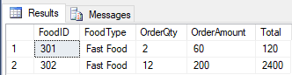

**4.e Display full detail of customer, total number of orders made and the overall total order amount made by the customer.**

SELECT Customer.CustName, Food.FoodName, Food.FoodType, Orderlist.OrderDate, Sum([OrderQty]*[OrderAmount]) AS [Total Amount], [OrderDate] AS [Orders]

FROM Food INNER JOIN (Customer INNER JOIN [Orderlist] ON Customer.CustID = Orderlist.CustID) ON Food.FoodID = Orderlist.FoodID

GROUP BY Customer.CustName, Food.FoodName, Food.FoodType, Orderlist.OrderDate, [OrderDate];

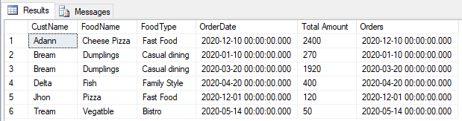

**4.f Update expiry hour for all food sold by restaurant name "High ways" (you may also use the available restaurant name inserted earlier) with additional 2 hours. You are required to show before and after update records.**

UPDATE Food

Set FoodExpiryHour = FoodExpiryHour + 2

where RestID = 200

**Before**

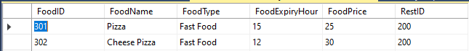

**After**

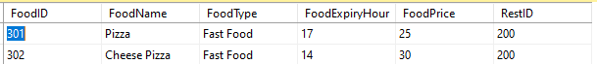

**4.f Display full customer name, food name, food type, order date and order price for all order delivered on the last 30 days.**

SELECT Customer.CustName, Food.FoodName, Food.FoodType, Food.FoodPrice, Orderlist.OrderDate, Sum([OrderQty]*[OrderAmount]) AS [Total Amount], [OrderDate] AS [Order Last 30 days]

FROM Food INNER JOIN (Customer INNER JOIN [Orderlist] ON Customer.CustID = Orderlist.CustID) ON Food.FoodID = Orderlist.FoodID

GROUP BY Customer.CustName, Food.FoodName, Food.FoodType, Food.FoodPrice, Orderlist.OrderDate, [OrderDate]<30;

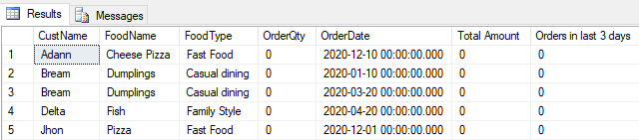

**4.e Modify the DELIVERY table by adding in new column entry for update status of delivery by each dispatch.**

alter table Delivery

add Status varchar(50)

**Before**

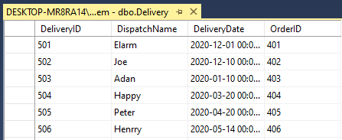

**After**

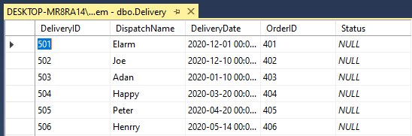

**5.Create ONE form to handle the Order-Entry. The form must be able to enter and display data.**

